***Please see more projects on page 2***

### Interesting Facts and Figures

Total Number of Pledges 6482

Total Amount Pledged £13,120.515

The largest donation £100,000

Total amount received to-date £12,159,749

Parish share of amount pledged £5,834,905

Diocese share of amount pledged £7,285,610

Total amount spent so far

- Parish Local Funds Amount Spent = £3,430,056

- Parish and Lay Formation Fund Spent=£1,191,631

- Renewing Facilities Fund Spent = £241,940

- Clergy Formation and Support Fund = £252,879

79 members of the clergy had pledged = £270,027

**Please complete your Living Our Faith pledge before you join the Parish driven campaign called ‘Our Parish’s Future’.**

If you need to know your **Living Our Faith** pledge end date then please contact Graham Palethorpe Tel: 02392 836518.

Please be assured that if you’re paying your pledge through **direct debit** **that it will stop automatically,** you do not have to do anything.

So many exciting new projects

To-date 212 projects have been approved or are waiting approval totalling £5,116,506. Recent projects include the support costs for 12 young men training for the priest hood, 10 men in training for the Diaconate. Grants have been made to Youth (for example, the Ignite Confirmation programme), Adult educational programmes such as the Certificate in Catechesis, Alpha, Bereavement Training, Parish Missions, and the provision of funding for buildings and maintenance projects, communications and education projects, and projects which involve acts of kindness and benevolence. The following are a list of the projects approved in November 2014 through to February 2015:-

Recent Local Parish Fund Allocations.

1. Horndean – Chairs for the hall (£705).
2. Tadley - Church Refurbishment (£13,200)
3. Farnborough Our Lady – Repair the external render to the Church and Presbytery £13,500)
4. Brockenhurst - Redecoration and refurbishment of the Presbytery (£8.339)

March, 2015

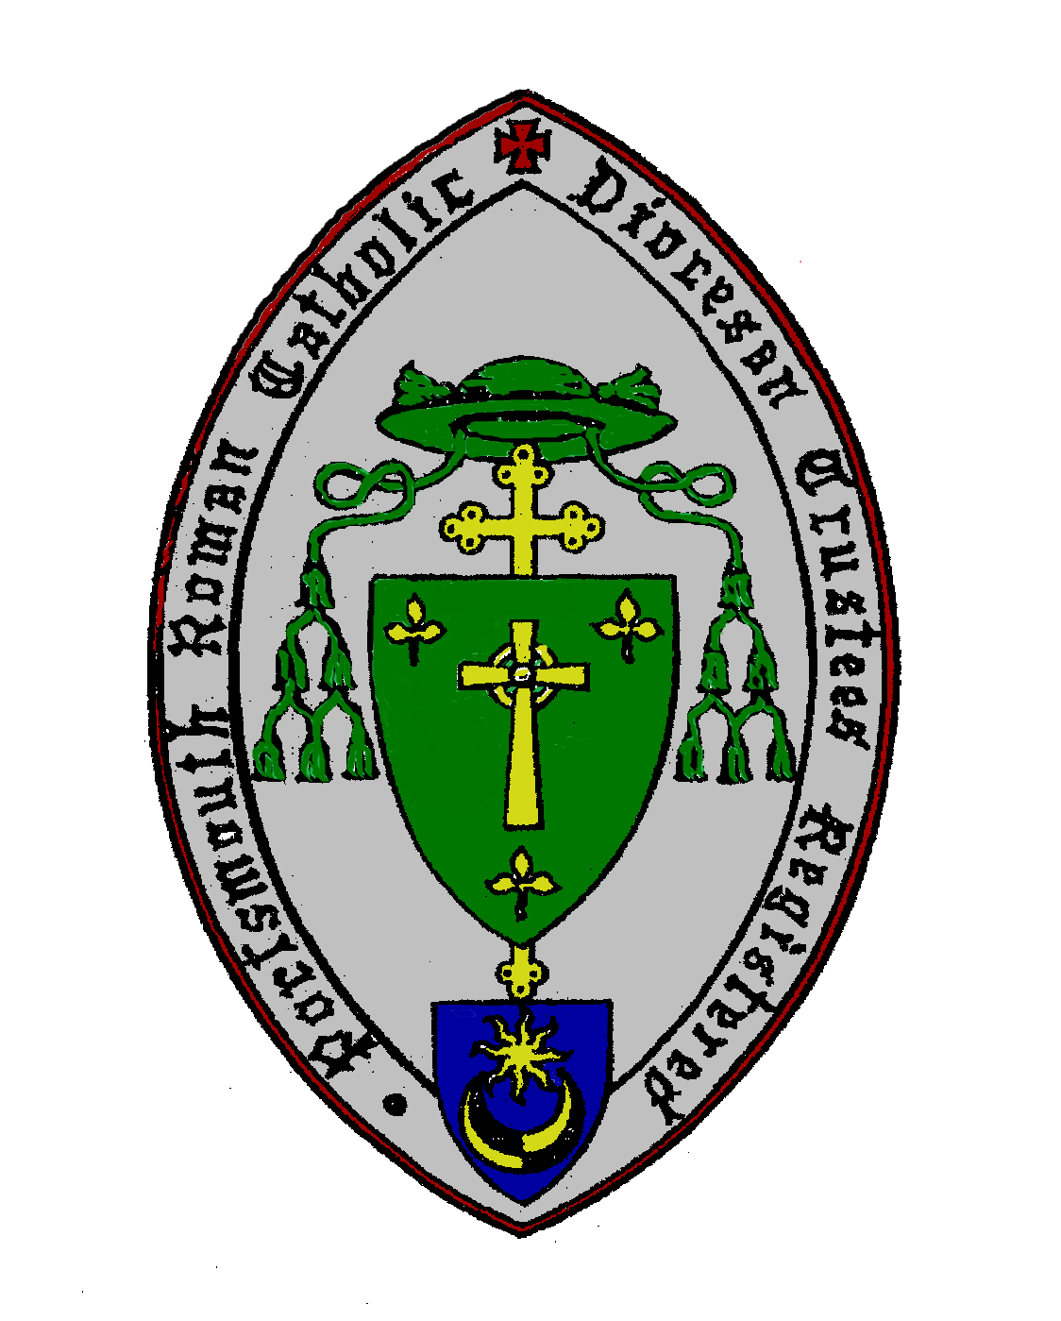

**Thank you to all Living Our Faith donors because you have pledged £13.1 Million** **of which £12.1 Million has been received**

**To-date £5.1 Million has been allocated to fund:**

2 – New Churches

5 - Clergy Training and Support Projects which includes:

12 - Men training for the Priesthood

10 – Men training for the Diaconate

5 – Catechists/Stewardship Co-ord Trained

9 – Programmes for Young People,

6 – Youth Workers,

72 – Programmes for Adults,

9 – Parish Missions,

1 – Vocations Conference funded,

68 – Church Refurbishment Projects,

12 – Parish Hall Renovations

23 – Other Projects.

# Donor Update – A big thank you

# **Recent Local Parish Fund Allocations (continued):**

1. Christchurch – Funds to repay Hall loan (£56,000)
2. Cathedral – Funds to repay parish loan (£31,479)

# **Recent Diocesan Lay Formation Fund Allocations**

# Funding support to eight candidates starting the 2 year Maryvale Certificate in Catechesis course (£8,046)

1. Havant PA – Echoes Catechetical Course for 25 parishioners facilitated by the Srs of St Joseph, St Dominic's Priory (£1,200)

1. NW Hants Pastoral Area – Three year’s funding for a Part-time Youth Worker (£37,500)
2. Southampton St Joseph and St Edmund – Echoes Catechetical Course facilitated by the Srs of St Joseph, St Dominic’s Priory (£960)

1. Windsor – Acorn Training Course for the Bereavement Group (£624)
2. Havant Pastoral Area - New Evangelisation DVDs by Fr Robert Budden (£400)
3. Jersey - Post of Marriage and Family Life Coordinator (£85,354)
4. St Swithun Wells – Alpha Training Course materials (£3,895)
5. All Parishes – Funding to help Youth attend the Ignite Confirmation preparation event (£5,000)
6. Windsor – Funding for a Sion Parish mission in 2016 (£3,950)

**Renewing Facilities Fund Allocations.**

1. Westbourne – Our Lady Immaculate. Re-roof the church (£24,000)

**Living Our Faith – A personal reflection by the Campaign Administrator**

As the Campaign Administrator I’ve been in a privileged position to see at first-hand how the money has been spent, and to have witnessed the rigor applied to each application for funding, and to learn that all requests for funding must originate from the grass roots up (from parish level) only. Importantly too, that all applications are in alignment with the Diocesan Plan ‘Go Out and Bear Fruit’ and the ‘New Evangelisation’. This overriding principle of ensuring that it’s the parishes (grass roots) that drive all funding requests is resulting in projects that are

meaningful to the parishioners themselves. They donate and they see the results. To date £5.1 million (a phenomenal sum of money) has been spent on local parish projects (acts of generosity, building and maintenance projects), or projects that will benefit parishes in the longer term (such as the training of new priests and deacons).

Through the provision of funding the **Living Our Faith** campaign has been an important enabler for the “New Evangelisation”, which has in turn encouraged our lay community to identify and share their talents (charisms) through volunteerism and evangelisation. This in turn has helped to create projects that provide a civic benefit such as ministries to the homeless, marginalised, and sick etc. To date there have been over 200 **Living Our Faith** projects, of which 72 projects have been all been about educating our lay parishioners (for example, missions through to individual educational courses). These projects have enabled those who participated to learn more about their faith, and to help them to become active disciples of Jesus and to share this love of God with others.

Graham Palethorpe

**Canon David Hopgood – A Thank you.**

Canon David Hopgood resigned as a Trustee of the Diocese at the end of 2014. I would like to give thanks to him here for his distinguished service as a Trustee, and as Chair of the Living our Faith Impact committee. Canon David’s period of trusteeship covers an extraordinary period - almost one-fifth of the life of the diocese! That is a remarkable service for which I know my predecessors, Bishop Emery and Bishop Hollis have been grateful, as, indeed, I certainly am too. Canon David’s work in chairing the Living our Faith Impact committee, offering careful and wise discernment as to the distribution of these generously-donated funds, has been invaluable. I thank him for the great pastoral sensitivity that he has shown, along with his tireless dedication. We are most grateful to you, Canon David.

Bishop Philip

# **Please Consider Leaving a Gift in Your Will**

Several of the donations to **Living Our Faith** have been legacies. When it comes to your will, it’s only right that your family and friends come first in your thoughts, but that doesn’t mean you can’t also leave a gift to a cause close to your heart. A gift in your will can make a vital difference to the Church in the Diocese of Portsmouth.

**Financial benefits of leaving a gift in your Will**

Legacies are generally exempt from inheritance tax, so a gift in your Will to your Church could be tax free for us and in some circumstances could reduce the amount of inheritance tax your loved ones are liable for. If you would like more information, please visit the HMRC Web site at <http://www.hmrc.gov.uk/individuals/giving/will.htm>

If you would like further information on leaving money to the campaign in your will, please contact:-

**Graham Palethorpe**

Living Our Faith Administrator

Telephone: **023 9283 6518**

**GPalethorpe@Portsmouthdiocese.org.uk**

.

*The Living Our Faith Committee exists to ensure that the funds generously given have an impact on the lifeof the Diocese – they will make sure this happens and report back regularly on the results.*

*Canon David Hopgood.*