Our relationship with Bamenda

The central African country, Cameroon split after World War I into a French-run zone and a smaller, British-controlled area. They were unified in 1961, but the English-speaking minority - Anglophones, about a fifth of the population, has complained of marginalization by the French majority for decades. The Anglophone regions make up the North West and South West regions of Cameroon.

Bamenda, also known as Abakwa and Mankon Town is a city in the Northwestern Cameroon and capital of the Northwest Region. Bamenda presently contains the highest number of English speaking Cameroonians.

In 1974, Bishop Worlock of Portsmouth and Bishop Paul Verdzekov of Bamenda initiated a twinning between the Diocese of Portsmouth and the Diocese of Bamenda which has lasted till now.

In 2019, we would be celebrating the 45th anniversary of the link with delegations from both dioceses visiting each other. The Catholic Church has been increasingly caught in the middle of an escalating Anglophone crisis with priests shot dead, property destroyed and frequent detentions by armed separatists.

Bishop Michael Bibi was detained twice by armed groups. On 5 December 2018 he attempted to travel from Bamenda, the capital of the North West region, to Kumba, 170 kilometres to the south west, intending to celebrate mass. However, on the road his car was stopped and held up by a group describing itself as the “Amba Boys”. “They threatened that they’re going to kill us,” said Bishop Michael Bibi of the Bamenda archdiocese, following a recent detention by armed separatists. The Amba Boys are one of a number of armed separatist groups fighting the Cameroonian security forces in the North West and South West of the country.

The unrest began in late 2016 in Bamenda with peaceful protests by teachers and lawyers against the dominance of the French language in schools and courts. It has escalated into a conflict in which armed splinter groups are killing soldiers and police officers, kidnapping government officials and harassing village chiefs they accuse of collaborating with the authorities.

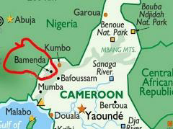

Christians caught in the crossfire

Bishop Bibi’s recent experiences on the road in Cameroon’s Anglophone regions are indicative of a greater threat facing priests. A number have been killed in recent violence while church property has also been targeted.

Father Alexander Sob of the Buea diocese was killed on the road in July. He was shot while sitting in a car. Gerard Anjiangwe, a seminarian, was killed in Bamessing village near Bamenda in October. “He was shot by the military and died on the spot,” said Bibi.

A Kenyan priest Cosmas Omboto, who was doing missionary work in Cameroon, was killed in November 2018. He was recently flown back and buried in his native Kisii. Some media reports suggested he was killed during a church service.

Displaced families

Sama Jude knew it was time to flee his home town in western Cameroon when he heard the sound of gunfire ringing above the roof of the University of Bamenda where he’s taught for four years.

As clashes between the nation’s army and separatist rebels intensified, the 41-year-old lecturer packed his bags and fled to the commercial capital, Douala, about 200 kilometers to the south.

“You never know when you’ll be hit by a bullet, maimed by a machete, arrested by government troops or kidnapped by the secessionists,” he said.

Jude is among hundreds of thousands of people forced to flee an increasingly bloody revolt in Cameroon’s English-speaking Northwest and Southwest regions that risks erupting into full-blown civil war. The violence is escalating as the nation emerges from its presidential elections in October 2018, where the 85-year-old Paul Biya extended his rule as Africa’s second longest serving leader.

More than half the city’s population of about 400,000 have already fled their homes in the last few months either to safer neighbourhoods or to mainly French-speaking towns and cities unaffected by the conflict.

How can we help

The Portsmouth Bamenda Committee serves this link on behalf of the Diocese as a channel of information and mutual support, and by administering the funds that are contributed from the annual Bamenda Sunday collection and from parishes and other organisations/institutions who have taken on specific projects such as Faith, Social Welfare, Health and Education.

In the last financial year, the Portsmouth Bamenda Committee has collectively sent £108,100 to Bamenda to support various projects. In these difficult times, your support is needed all the more, so please give generously to all Bamenda Sunday Collections and gift aid your donation if you can.

We wish to thank Chris White for his amazing work over the past few years for St Joseph Bracknell Parish. Taking over from Chris is Kenneth Maimo or Cornelis Fru Ndi. If you have any questions or wish to discuss further, please do not hesitate to contact. Both grew up in Bamenda and attended one of the Catholic Schools in the area (Sacred Heart Mankon College). This cause is very close to their hearts and they are set to strengthen and support the link between the Diocese of Portsmouth and Diocese of Bamenda in 2019.

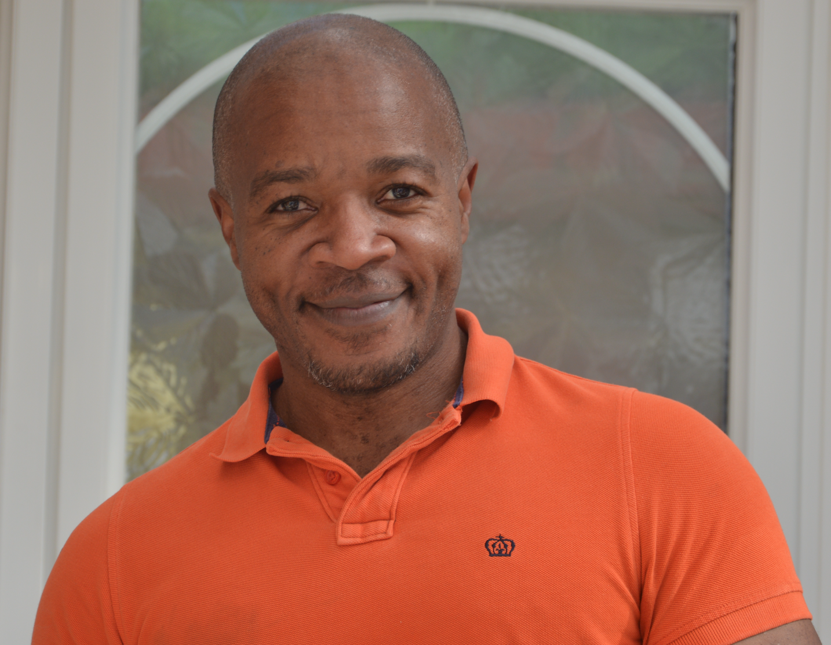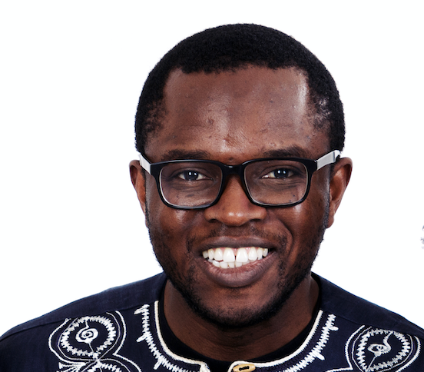
Kenneth Cornelis

